Part A

Section 3: Comprehension [20 Marks]

Read the text and then answer the question which follow. Write your answers in the spaces provided.

AMMONIA IN THE WORLD

Ammonia is one of the most important chemicals being manufactured today. Of the total amount of ammonia produced 80% is used to make ‘nitrogenous’ fertilisers. Other products made from ammonia include synthetic fibres like nylon, dyes, plastics and explosives.

Nitrogen compounds are a major part of the protein that we need in our diet. Protein comes from meat or, more directly, from vegetables like beans. The protein in meat comes from plants that the animals eat, such as grain. Fertilisers help all plants to grown; on average, a tonne of ammonia applied as fertiliser produces 15 tonnes of grain.

By the year 2000, the world’s population will be almost twice as high as it was in 1970. The largest growth will occur in the developing countries. All these people will only be fed by improving the efficiency of farming methods and particularly by increasing the use of nitrogenous fertilisers.

Making Ammonia

Ammonia plants have always been situated close to their sources of:

- energy, usually natural gas, but occasionally oil, or even coal where it is exceptionally cheap.
- water, usually required in fairly large quantities for the process.
- transport, by sea, rail or road.

The formulae for ammonia is NH₃. It is made by reacting nitrogen with hydrogen in the
‘Haber Process’. The equation for this reaction is:

N_{2(g)} + 3H_{2(g)} 2NH_{3(g)} ΛH = -92kJ

To get a reasonable yield of ammonia, the chemical engineers responsible for the plant have to be very smart. They use these techniques:

- The reaction is done at a high pressure (300 atmospheres or 3x10⁷ Pascals).
- An iron catalyst is used.
- The ammonia produced is removed as it is made.
- The unused nitrogen and hydrogen are recycled.
- The reaction is not left long enough to reach equilibrium. Only about 15% of the possible
yield of ammonia is made.
- The reaction is done at a ‘middle’ temperature: about 500°C.
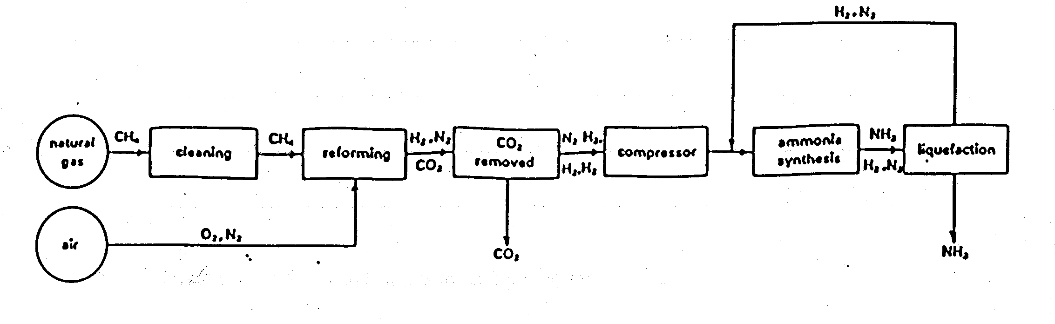
Below is a simplified diagram to show how ammonia is made by the ‘Haber Process’.

Large chemical plants take a long time to start up and shut down. It would take about two to three days for ‘cold’ plant to make any ammonia at all. Plants are therefore operated round the clock, 365 days a year, except for breakdowns and overhauls.

- Explain two factors that determine where an ammonia production plant should be built?

(2 marks)

- Why is ammonia production increasing?

(1 mark)

- In the beginning of the production of ammonia what mainly supplies the

Nitrogen atoms?
Hydrogen atoms?
(2 marks)

- To remove O₂ from the air methane is burnt. Write a balanced equation to represent this reaction.

(1 mark)

Referring to the flow chart what is the name given to this part of the production process.

(1 mark)
- Clearly explain why the production of ammonia is done at such high pressures?

(2 marks)

- Explain the role a catalyst has in an equilibrium reaction.

(2 marks)

- Clearly explain why the reaction is not done at too high a temperature.

(2 marks)

- If nitrogen and hydrogen react in a closed vessel at pressures and temperatures used in the Haber Process, only about 20% of the nitrogen and hydrogen ate converted to ammonia. Explain how industry ensures that all of the nitrogen and hydrogen reacts to produce ammonia.

(3 marks)

- Explain why the production of ammonia depletes our energy resources?

(1 mark)

- Draw an electron dot diagram of an ammonia molecule

(1 mark)

- Is ammonia gas [NH_{3(g)}] soluble in water ? Explain why.

(2 marks)

End of Section 3

